

**CSP 352 LAB FILE**

**WEB TECHNOLOGIES LAB**

|  |  |
| --- | --- |
| **Name :** | Ritik Kumar Mishra |
| **System I’d:** | 2018006493 |
| **Roll Number:** | 180101259 |
| **Class:** | CSE - C (AI & ML) |
| **Year & Semester:** | 3rd Year [6th Semester] |
| **Mentor:** | Ms. Anamika Mitra |

**Index**

|  |  |  |  |
| --- | --- | --- | --- |
| **S.no.** | **Experiment** | **Date** | **Page-No** |
| 1 | Create your profile with HTML & CSS | 20-1-21 | 3-12 |
| 2 | Create Time Table with HTML & CSS | 27-1-21 | 13-16 |
| 3 | Create a web page to show working of ordered, unordered, dictionary and nested list. | 3-2-21 | 17-21 |
| 4 | Create a registration form with HTML & CSS. | 10-2-21 | 22-24 |
| 5 | Embed audio, video into your HTML page. | 17-2-21 | 25-27 |
| 6 | Create HTML page to show horizontal, vertical and mixed layout of frames. | 24-2-21 | 28-29 |
| 7 | Create a navigation bar with CSS. | 10-3-21 | 30-32 |
| 8 | Write validation function and on submit property of button on form. | 17-3-21 | 33-35 |
| 9 | 1. Write java-script program to change background color. 2. Create a calculator using java-script. 3. Create java-script program for toggle button. | 24-3-21 | 36-39 |
| 10 | 1. Create jQuery program to hide an element. 2. Create jQuery program to show alert when we hover an element. 3. Show the effects of SlideUp, SlideDown and fade. | 31-3-21 | 40-43 |

**Date: 20-1-21**

**Experiment 1: Create your profile with HTML & CSS.**

**Solution**:

<!DOCTYPE html>

<html lang="en">

<head>

<meta charset="UTF-8">

<meta name="viewport" content="width=device-width, initial-scale=1.0">

<link rel="shortcut icon" href="/static/images/icon2.png" type="image/x-icon">

<title>Ritik Kumar Mishra</title></head>

<body>

<div class="main-container">

<div class="aside">

<div class="nav-toggler">

<span></span>

<span></span>

<span></span></div>

<div class="aside-inner">

<div class="logo">

<a>Ritik Kumar Mishra</a></div>

<ul class="nav">

<li><a class="active" href="#home">Home<i class="fa fa-home"></i></a></li>

<li><a href="#about">Know me<i class="fa fa-user-circle"></i></a></li>

<!-- <li><a href="#services">Project<i class="fa fa-list"></i></a></li> -->

<li><a href="#project">Project<i class="fa fa-list"></i></a></li>

<li><a href="#blog">Blog<i class="fa fa-envelope"></i></a></li>

<li><a href="#contact">Contact Me<i class="fa fa-comments"></i></a></li>

{% if user.is_authenticated %}

<li><a href="/logout">Logout({{request.user}})<i class="fa fa-user"></i> </a></li>

{% else %}

<li><a href="/sign">Signin/Login<i class="fa fa-user"></i></a></li>

{% endif %}

</ul>

<div class="copyright-text">

Always Keep Smiling !!</div></div></div>

<div class="main-content">

<!-- Home Section  -->

<section class="home section active" id="home">

<div class="container">

<div class="intro">

<img src="/static/images/icon.png" alt="profile" class="shadow-dark">

<h1>Ritik Kumar Mishra</h1>

<p>I am a Machine Learning Student.</p>

<div class="social-link">

<a href="https://twitter.com/ritik1501" target="_blank"><i class="fa fa-twitter"></i></a>

<a href="https://www.facebook.com/ritik1501" target="_blank"><i

class="fa fa-facebook"></i></a>

<a href="https://www.instagram.com/ritik_1501/" target="_blank"><i

class="fa fa-instagram"></i></a>

<a href="https://github.com/ritik1501" target="_blank"><i class="fa fa-github"></i></a>

<a href="https://www.linkedin.com/in/ritik1501/" target="_blank"><i

class="fa fa-linkedin"></i></a></div></div></div>

</section>

<!-- Home Section END -->

<!-- About Section -->

<section class="about section" id="about">

<div class="container">

<div class="row">

<div class="section-title padd-15">

<h2>About Me</h2></div></div>

<div class="row">

<div class="about-content padd-15">

<div class="row">

<div class="about-text padd-15">

<h3>I'm Ritik Kumar Mishra. <span>I am a Machine Learning Student</span> </h3>

<p>Hello!! My self Ritik Kumar Mishra. I am a B.Tech. Student at Sharda University. My stream is Computer Science with specialization in Artificial Intelligence and Machine Learning. I have interest in web development also. I have created some projects of machine learning. I use my web development skills to deploy machine

learning projects.</p></div></div>

<div class="row">

<div class="personal-info padd-15">

<div class="row">

<div class="info-item padd-15">

<p>Birthday : <span>1 May 2001</span></p></div>

<div class="info-item padd-15">

<p>Degree : <span>B.Tech.(Pursuing)</span></p></div>

<div class="info-item padd-15">

<p>Twitter : <a href="https://twitter.com/ritik1501"

target="_blank"><span>@Ritik1501</span></a></p></div>

<div class="info-item padd-15">

<p>City : <span>Greater Noida</span></p></div>

<div class="info-item padd-15">

<p>Phone : <a href="tel: +918076694256"><span>+918076694256 </span> </a> </p></div>

<div class="info-item padd-15">

<p>Email : <a href="mailto:mishraritik86@gmail.com"><span

class="web-tech">mishraritik86@gmail.com</span></a></p></div></div>

<div class="row">

<div class="buttons">

<a href="/static/Ritik Kumar Mishra.pdf" class="btn"

target="_blank">Download CV</a>

<a href="#contact" data-section-index="1" class="btn hire-me"> Contact Me </a></div></div></div>

<div class="skills padd-15">

<div class="row">

<div class="skill-item padd-15">

<h4>Python</h4>

<div class="progress">

<div class="progress-in" style="width: 85%;"></div>

<div class="skill-percent">85%</div></div></div>

<div class="skill-item padd-15">

<h4>JavaScript</h4>

<div class="progress">

<div class="progress-in" style="width: 80%;"></div>

<div class="skill-percent">80%</div></div></div>

<div class="skill-item padd-15">

<h4>Django</h4>

<div class="progress">

<div class="progress-in" style="width: 70%;"></div>

<div class="skill-percent">70%</div></div></div>

<div class="skill-item padd-15">

<h4>React</h4>

<div class="progress">

<div class="progress-in" style="width: 60%;"></div>

<div class="skill-percent">60%</div></div></div>

<div class="skill-item padd-15">

<h4>Machine Learning</h4>

<div class="progress">

<div class="progress-in" style="width: 60%;"></div>

<div class="skill-percent">60%</div></div></div></div></div></div>

<div class="row">

<div class="education padd-15">

<h3 class="title">Education</h3>

<div class="row">

<div class="timeline-box padd-15">

<div class="timeline shadow-dark">

<div class="timeline-item">

<div class="circle-dot"></div>

<h6 class="timeline-date"><i class="fa fa-calendar"></i>2015-16 </h6>

<h4 class="timeline-title">Matriculation</h4>

<p class="timeline-text">I've completed my Matriculation education from Sarvhitkari S.S. Vidya Mandir School, Barnala, Punjab(Punjab School Education Board) with first division and 96% marks. </p> </div>

<div class="timeline-item">

<div class="circle-dot"></div>

<h6 class="timeline-date"><i class="fa fa-calendar"></i>2017-18 </h6>

<h4 class="timeline-title">Higher Secondary</h4>

<p class="timeline-text">I've completed my higher Secondary eduction from S.D.College, Barnala, Punjab (Punjab School Education Board) with Non-medical Stream. I secured first division and 89% marks in the examination.</p>

</div>

<div class="timeline-item">

<div class="circle-dot"></div>

<h6 class="timeline-date"><i

class="fa fa-calendar"></i>2018-22(Pursuing)</h6>

<h4 class="timeline-title">Bachelor Degree</h4>

<p class="timeline-text">Currently I'm pursuing my bachelor's degree

from Sharda University in the stream of Computer and Science. My

specialization is Artificial Intelligence and Machine Learning.

</p></div></div></div></div></div>

<div class="projects padd-15">

<h3 class="title">Projects</h3>

<div class="row">

<div class="timeline-box padd-15">

<div class="timeline shadow-dark">

<div class="timeline-item">

<div class="circle-dot"></div>

<h6 class="timeline-date"><i

class="fa fa-snowflake-o"></i>Internship Project</h6>

<h4 class="timeline-title">Covid-19 Predictor</h4>

<p class="timeline-text">We made a WebApp for covid-19 prediction

using machine learning as our College Internship Project. This

webapp takes body symptoms of users and predict wheather they

are affected or not.</p></div>

<div class="timeline-item">

<div class="circle-dot"></div>

<h6 class="timeline-date"><i class="fa fa-microphone"></i>Semester

Project</h6>

<h4 class="timeline-title">Speech Emotion Recognition</h4>

<p class="timeline-text">This command line project is very helpful

for getting the emotions of users with the help of their voice

samples or real time voice. This is also capable to generate the

subtitle of voice sample.</p></div>

<div class="timeline-item">

<div class="circle-dot"></div>

<h6 class="timeline-date"><i class="fa fa-medkit"></i>Semester

Project</h6>

<h4 class="timeline-title">Drug Prescription System</h4>

<p class="timeline-text">This WebApp helps user to select the

medicines of particular disease on the basis of other body

problems. This webapp uses machine learning to find the better

result for the user.</p></div></div></div></div></div></div></div></div></div>

</section>

<!-- About Section End -->

<!-- Portfolio Section  -->

<section class="portfolio section" id="project">

<div class="container">

<div class="row">

<div class="section-title">

<h2>Project</h2></div></div>

<div class="row">

<div class="portfolio-filter padd-15">

<button type="button" class="active" data-filter="all">All</button>

<button type="button" data-filter="web-design">Web Design</button>

<button type="button" data-filter="machine-learning">Machine Learning</button>

<button type="button" data-filter="javascript">JavaScript</button></div>

<div class="row">

<div class="portfolio-item padd-15" data-category="javascript">

<div class="portfolio-item-inner">

<div class="portfolio-img">

<img src="https://raw.githubusercontent.com/ritik1501/Post-Master-Postman-Clone/master/images/postmaster.png"

alt="Portfolio"></div>

<div class="portfolio-info">

<h4>Postman Clone</h4>

<p>It is a postman clone. This website provides you the all access to use the

get and post urls and also show you the responses to copy and use freely.</p>

<a href="https://github.com/ritik1501/Post-Master-Postman-Clone"

target="_blank">Get the Code</a>

<div class="icon">

<i class="fa fa-search"></i></div></div></div></div>

<div class="portfolio-item padd-15" data-category="machine-learning">

<div class="portfolio-item-inner">

<div class="portfolio-img">

<img src="https://raw.githubusercontent.com/ritik1501/Covid-Predictor/master/static/image/medicine.jpg"

alt="Portfolio"></div>

<div class="portfolio-info">

<h4>Drug-Prescriber</h4>

<p>A WebApp made with machine-learning to predict the drug based on body's

symptoms and other body problems to prevent the reaction of unnecessary

medicines.</p>

<a href="https://github.com/ritik1501/Drug-Prescriber" target="_blank">Get the

Code</a>

<div class="icon">

<i class="fa fa-search"></i></div></div></div></div>

<div class="portfolio-item padd-15" data-category="javascript">

<div class="portfolio-item-inner">

<div class="portfolio-img">

<img src="https://raw.githubusercontent.com/ritik1501/News-Website/master/images/news.png"

alt="Portfolio"></div>

<div class="portfolio-info">

<h4>News Website</h4>

<p>This website helps you to find out the daily fresh news from various sources

with the help of API.</p>

<a href="https://github.com/ritik1501/News-Website" target="_blank">Get the

Code</a>

<div class="icon">

<i class="fa fa-search"></i></div></div></div></div>

<div class="portfolio-item padd-15" data-category="web-design">

<div class="portfolio-item-inner shadow-dark">

<div class="portfolio-img">

<img src="https://raw.githubusercontent.com/ritik1501/Website-Starry-Banner-/master/images/starry.png"

alt="Portfolio"></div>

<div class="portfolio-info">

<h4>Background Cover</h4>

<p>A website background cover made with HTML,CSS and javascript having

animations of moving cloud and stars.</p>

<a href="https://github.com/ritik1501/Website-Starry-Banner-"

target="_blank">Get the Code</a>

<div class="icon">

<i class="fa fa-search"></i></div></div></div></div>

<div class="portfolio-item padd-15" data-category="web-design">

<div class="portfolio-item-inner shadow-dark">

<div class="portfolio-img">

<img src="https://raw.githubusercontent.com/ritik1501/Background-Rain-Effect/master/img/rain%20image.png"

alt="Portfolio"></div>

<div class="portfolio-info">

<h4>Background Rain Effect</h4>

<p>A website template for rain effect with rain animations and color changing

effects using pure CSS.</p>

<a href="https://github.com/ritik1501/Background-Rain-Effect"

target="_blank">Get the Code</a>

<div class="icon">

<i class="fa fa-search"></i></div></div></div></div>

<div class="portfolio-item padd-15" data-category="web-design">

<div class="portfolio-item-inner shadow-dark">

<div class="portfolio-img">

<img src="https://raw.githubusercontent.com/ritik1501/Mini-Calender/master/images/calender.png"

alt="Portfolio"></div>

<div class="portfolio-info">

<h4>Mini-Calender</h4>

<p>A website template of mini calendar made with CSS and JavaScript.</p>

<a href="https://github.com/ritik1501/Mini-Calender" target="_blank">Get the

Code</a>

<div class="icon">

<i class="fa fa-search"></i></div></div></div></div>

<div class="portfolio-item padd-15" data-category="machine-learning">

<div class="portfolio-item-inner shadow-dark">

<div class="portfolio-img">

<img src="https://raw.githubusercontent.com/ritik1501/Covid-Predictor/master/static/image/corona.jpg"

alt="Portfolio"></div>

<div class="portfolio-info">

<h4>Covid-19 Predictor</h4>

<p>A WebApp for predicting the covid-19 on the basis of body symptoms and

physical contact data. It also consist of dashboard to see the covid real

time data.</p>

<a href="https://github.com/ritik1501/Covid-Predictor" target="_blank">Get the

Code</a>

<div class="icon">

<i class="fa fa-search"></i></div></div></div></div></div></div></div>

</section>

<!-- Portfolio Section End -->

<!-- Blog Section  -->

<section class="blog section" id="blog">

<div class="container">

<div class="row">

<div class="section-title">

<h2>Latest Blog</h2></div></div>

<div class="row">

{% if allPosts|length > 0 %}

{% for post in allPosts %}

<div class="blog-item padd-15">

<div class="blog-item-inner shadow-dark">

<div class="blog-img">

<img src="https://images.freeimg.net/rsynced_images/blog-1445367_1280.jpg"

alt="Blog-image">

<div class="blog-date">{{post.timestamp|truncatewords:1}}</div></div>

<div class="blog-info">

<h4 class="blog-title">{{post.title}}</h4>

<p class="blog-description">{{ post.content|safe|truncatewords:40 }}</p>

<p class="blog-tags"><a href="/blog/{{post.slug}}"> Learn More>></a></p>

</div></div></div>

<div class="blog-item padd-15">

</div></div>

</section>

<!-- Blog Section End -->

<!-- Contact Section  -->

<section class="contact section" id="contact">

<div class="container">

<div class="row">

<div class="section-title">

<h2>Contact Me</h2>

</div></div>

<div class="row">

<div class="contact-info-item padd-15">

<a href="https://www.linkedin.com/in/ritik1501/" target="_blank">

<div class="icon"><i class="fa fa-linkedin"></i></div>

<h4>LinkedIn</h4>

<p>@ritik1501</p>

</a></div>

<div class="contact-info-item padd-15">

<a href="https://goo.gl/maps/9CcbRbnuHmUEzQiW9" target="_blank">

<div class="icon"><i class="fa fa-map-marker"></i></div>

<h4>City</h4>

<p>Greater Noida, UP</p>

</a></div>

<div class="contact-info-item padd-15">

<a href="mailto: mishraritik86@gmail.com">

<div class="icon"><i class="fa fa-envelope"></i></div>

<h4>Email</h4>

<p>mishraritik86@gmail.com</p>

</a></div></div>

<form action="/connect" method="POST">

{% csrf_token %}

<div class="row">

<div class="contact-form padd-15">

<div class="row">

<div class="form-item col-6 padd-15">

<div class="form-group">

<input type="text" class="form-control" placeholder="Name" name="name"

required></div></div>

<div class="form-item col-6 padd-15">

<div class="form-group">

<input type="text" class="form-control" placeholder="Email" name="email"

required></div></div></div>

<div class="row">

<div class="form-item col-12 padd-15">

<div class="form-group">

<input type="text" class="form-control" placeholder="Subject" name="subject"

required></div></div></div>

<div class="row">

<div class="form-item col-12 padd-15">

<div class="form-group">

<textarea type="text" class="form-control" placeholder="Message" cols="8"

name="content" required></textarea>

</div></div></div>

<div class="row">

<div class="col-12 padd-15">

<button type="submit" class="btn">Send Message</button>

</div></div></div></div>

</form></div>

</section>

<!-- Contact Section End -->

</div>

<!-- Main Content  -->

</div>

<div class="style-switcher">

<div class="toggle-style-switcher">

<i class="fa fa-cog"></i></div>

<h4>Style Switcher</h4>

<ul>

<li><a href="javascript:void(0)" title="red" style="background-color: #E8112D;"

onclick="setActiveStyle('red')"></a></li>

<li><a href="javascript:void(0)" title="green" style="background-color: #138808;"

onclick="setActiveStyle('green')"></a></li>

</ul>

<h4>Body Skin</h4>

<label for="dark" id="dark-text">

<input type="checkbox" id="dark" class="body-skin" name="body-style" value="dark">Dark Mode

</label></div>

<div class="lightbox">

<div class="lightbox-content">

<div class="lightbox-close">&times;</div>

<img src="" alt="Image" class="lightbox-img">

<div class="lightbox-caption">

<div class="caption-text"></div>

<div class="caption-counter"></div>

</div>

<div class="caption-data"></div>

</div>

</body>

</html>

**Output:**

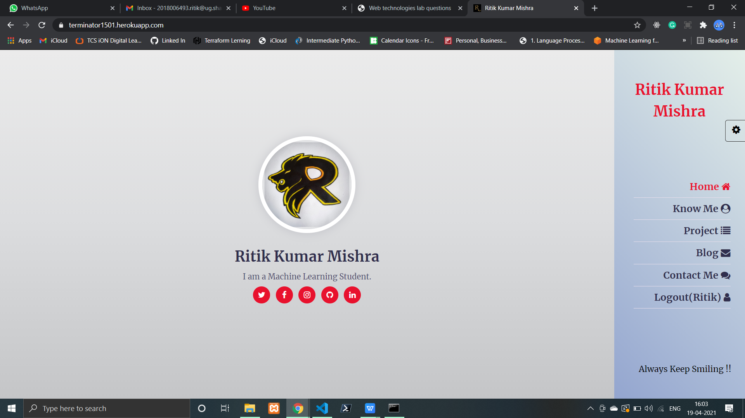

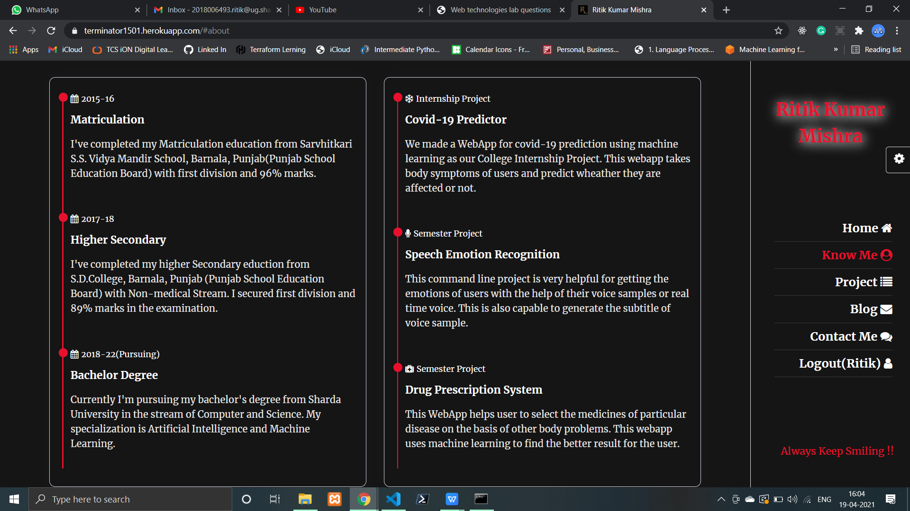

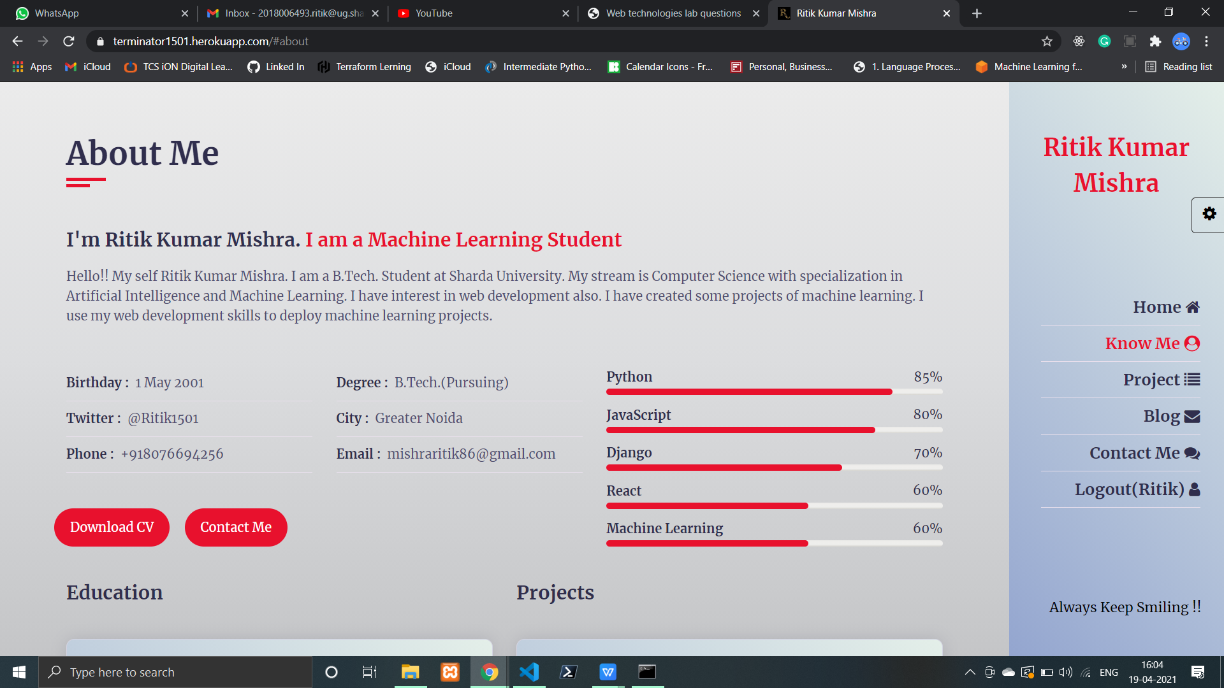

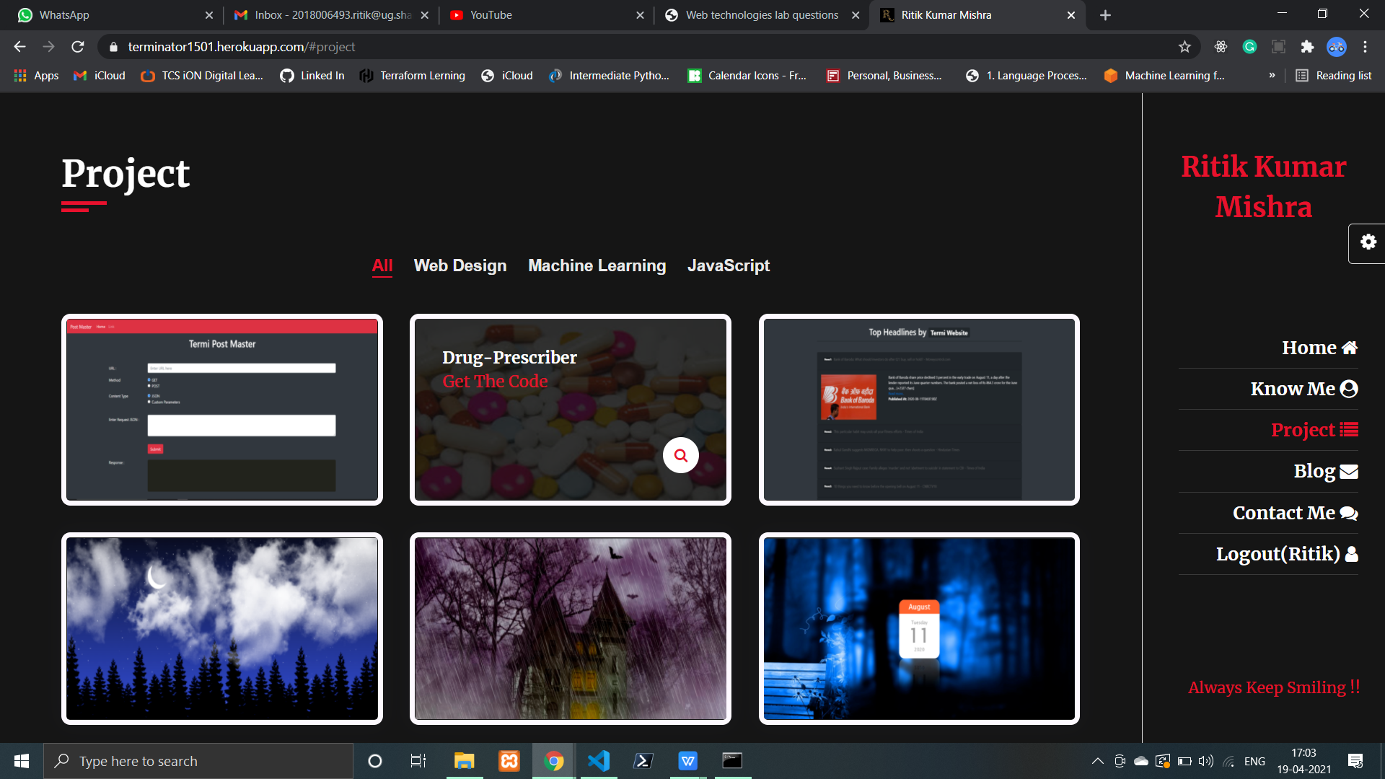

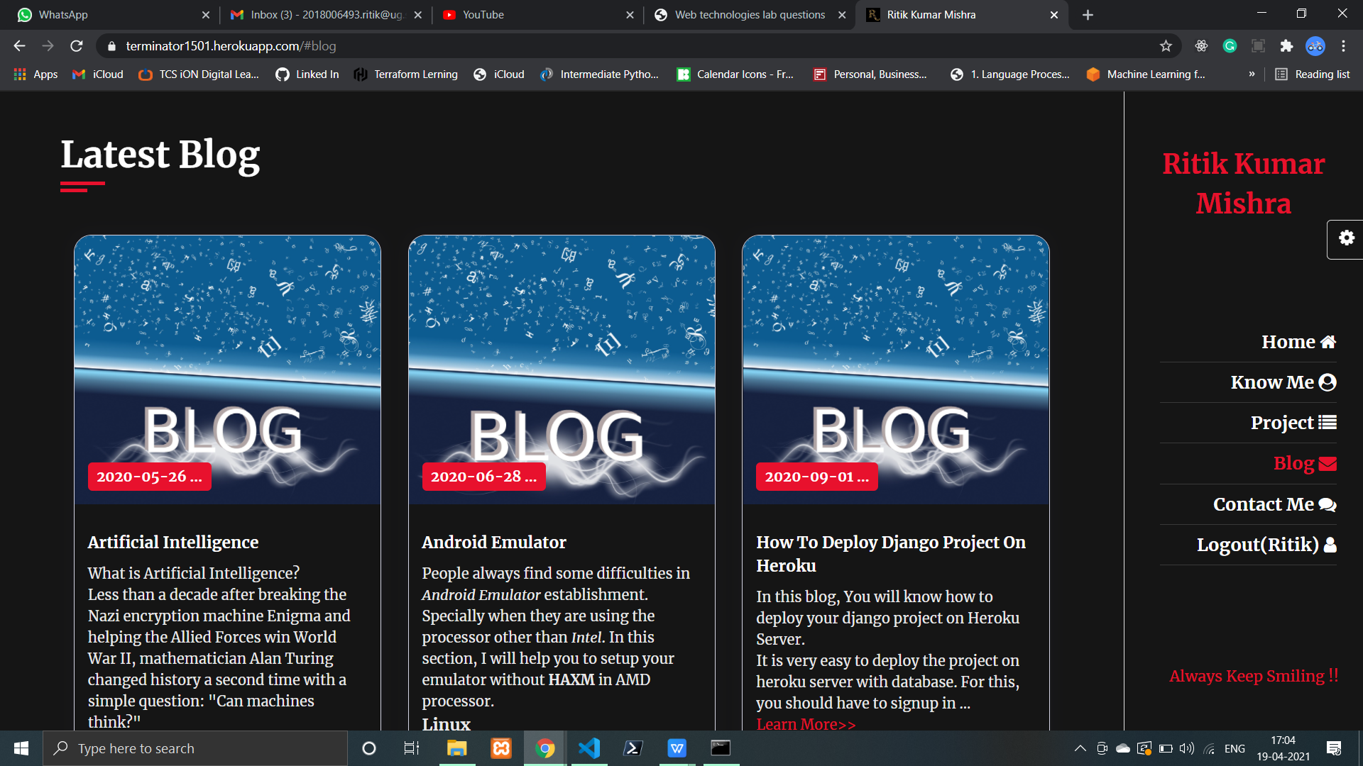

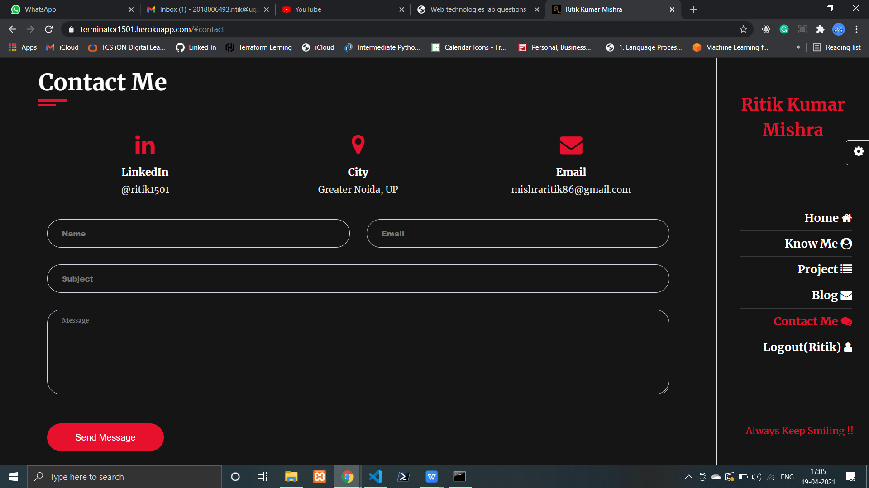

**Date: 27-1-21**

**Experiment 2: Create a table to show the time table of your class.**

**Solution:**

<!DOCTYPE html>

<html lang="en">

<head>

<meta charset="UTF-8">

<meta name="viewport" content="width=device-width, initial-scale=1.0">

<title>Time Table</title>

<link rel="stylesheet" href="style.css"></head>

<body>

<table align="center" width="400" border="5">

<tr align="center">

<th></th>

<th>1<br>8:45-9.35</th>

<th>2<br>9:40-10:30</th>

<th>3<br>10:35-11:25</th>

<th>4<br>11:30-12:20</th>

<th>5<br>12:25-1:15</th>

<th>6<br>1:20-2:10</th>

<th>7<br>2:15-3:05</th>

<th>8<br>3:10-4:00</th></tr>

<tr align="center">

<th>Monday</th>

<td class="hmm305" style="white-space: nowrap;">HMM305<br> 208(B-1)<span> DIV</span></td>

<td class="cse031" style="white-space: nowrap;">CSE031 <br>304(B-3)<span> DIP G-1</span> <span> DSI</span>

<hr>

CSE032 <br> CNS <span> MEC </span>

<hr>

CSE031<br>209 (B-1)<span> DIP G-2<span> DHR</td>

<td class="csa302" style="white-space: nowrap;">CSA302<br>208(B-1) <span> VIJ</td>

<td class="csa041" style="white-space: nowrap;">CSA041<br>209(B-1) <span> DSI G-1

<hr> CA041 <br> 208(B-1) <span> DGR G-2</td>

<td class="cse031" style="white-space: nowrap;">CSE031<br> 106(B-1)<span> DIP G-1<span> DSI</td>

<td class="hmm305" style="white-space: nowrap;">HMM305<br> 208(B-1) <span> DIV</td>

<td class="cse352" style="white-space: nowrap;">CSE352<br> 208(B-1) <span> ANM</td>

<td class="csa301" style="white-space: nowrap;">CSA301<br> 208(B-1) <span> JAY</td></tr>

<tr align="center">

<th>Tuesday</th>

<td class="mtr" style="white-space: nowrap;">MTR <br>208(B-1)<span> G-2<span> MKG</td>

<td class="hmm305" style="white-space: nowrap;">HMM305<br> 208(B-1) <span> DIV</td>

<td></td>

<td class="csa041" style="white-space: nowrap;">CSA041<br>209(B-1) <span> DSI G-1

<hr> CA041 <br> 208(B-1) <span> DGR G-2</td>

<td class="cse031" style="white-space: nowrap;"> CSE031<br> 209(B-1)<span> DIP G-2<span> DHR</td>

<td class="cse031" style="white-space: nowrap;">CSE031<br>106(B-1)<span> DIP G-1<span> DSI</td>

<td class="csp396" colspan="2" style="white-space: nowrap;">CSP396<br> 214-C(B-1)<span>G-1</span><span> DGR

<hr>

CSP392<br> 315(B-1)<span>G-2</span><span> DNR</span> </td></tr>

<tr align="center">

<th>Wednesday</th>

<td class="cse032" style="white-space: nowrap;">CSE032<br>CNS <span> MEC</span>

<hr> CSE031 <br> 209(B-1)<span> DIP G-2</span><span> DHR</span></td>

<td class="csa041" style="white-space: nowrap;">CSA041<br>209(B-1) <span> DSI G-1

<hr> CSA041 <br> 208(B-1) <span> DGR G-2</td>

<td class="arp302" style="white-space: nowrap;">ARP302<br> 208(B-1) <span> AB</td>

<td class="arp302" style="white-space: nowrap;">ARP302<br> 208(B-1) <span> NB</td>

<td></td>

<td class="csa301" style="white-space: nowrap;">CSA301<br> 208(B-1) <span> JAY</td>

<td class="csp352" colspan="2" style="white-space: nowrap;">CSP352<br> 013(B-1)<span> G-1</span><span> ANM

<hr>

CAL302<br> 315(B-1)<span> G-2</span><span> VIJ</span> </td>

</tr>

<tr align="center">

<th>Thursday</th>

<td class="csa302" style="white-space: nowrap;">CSA302<br>208(B-1) <span> VIJ</td>

<td class="cse352" style="white-space: nowrap;">CSE352<br>208(B-1) <span> ANM</td>

<td class="cse041" style="white-space: nowrap;">CSE041<br>208(B-1)<span> SPM<span> DAA</td>

<td class="cse041" style="white-space: nowrap;">CSE041<br>208(B-1)<span> SPM<span> DAA</td>

<td class="csp392" colspan="2" style="white-space: nowrap;">CSP392<br> 315(B-1)<span> G-1</span><span> DNR

<hr>

CSP352<br> 211-B(B-1)<span> G-2</span><span> ANM</span> </td>

<td class="csa301" style="white-space: nowrap;">CSA301<br>208(B-1) <span> JAY</td>

<td class="csa302" style="white-space: nowrap;">CSA302<br>208(B-1) <span> VIJ</td></tr>

<tr align="center">

<th>Friday</th>

<td class="cse352" style="white-space: nowrap;">CSE352<br>208 (B-1)<span> ANM</td>

<td class="cse041" style="white-space: nowrap;">CSE041<br>208 (B-1)<span> SPM<span> DAA</td>

<td class="arp302" style="white-space: nowrap;">ARP302<br> 208(B-1) <span> AB</td>

<td class="mtr" style="white-space: nowrap;">MTR <br>208 (B-1)<span> G-2<span> MKG</td>

<td class="cse032" style="white-space: nowrap;">CSE032<br>CNS <span> MEC</td>

<td></td>

<td class="cal302" colspan="2" style="white-space: nowrap;">CAL302<br> 211-C(B-1)<span>G-1</span><span> VIJ</span>

<hr>

CSP396<br> 308-A(B-1)<span> G-2</span><span> DGR </td></tr></table>

</body></html>

**Style.CSS**

span{

    margin-left: 5px; }

table{

    margin: auto;

    padding: 0;

    text-align: center; }

th{

    background-color: rgba(138, 117, 233, 0.9);}

hr{

    border-color: blanchedalmond;

    background-color: blanchedalmond; }

.mtr{

    background-color: rgba(255,138,144,0.7);

    color: black; }

.hmm305{

    background-color: rgba(255,138,144,0.8);

    color: lavenderblush; }

.csa302{

    background-color: hsla(120,100%,50%,0.5);

    color: black; }

.arp302{

    background-color: hsl(180, 50%, 50%);

    color: lavenderblush; }

.csa301{

    background-color: hsl(200, 80%, 20%);

    color: lavenderblush; }

.cse352{

    background-color: hsla(56,100%,50%,0.8);

    color: black; }

.csa041{

    background-color: hsl(100, 80%, 20%);

    color: lavenderblush; }

.cse041{

    background-color: hsla(200, 80%, 20%, 0.6);

    color: lavenderblush; }

.cse031{

    background-color: rgba(54, 252, 54, 0.5);

    color: black; }

.cse032{

    background-color: #273d58;

    color: lavenderblush; }

.cal302{

    background-color: #999;

    color: lavenderblush; }

.csp396{

    background-color: rgb(248, 76, 76);

    color: lavenderblush; }

.csp352{

    background-color: rgb(76, 151, 248);

    color: lavenderblush; }

.csp392{

    background-color: rgb(172, 94, 152);

    color: lavenderblush; }

**Output:**

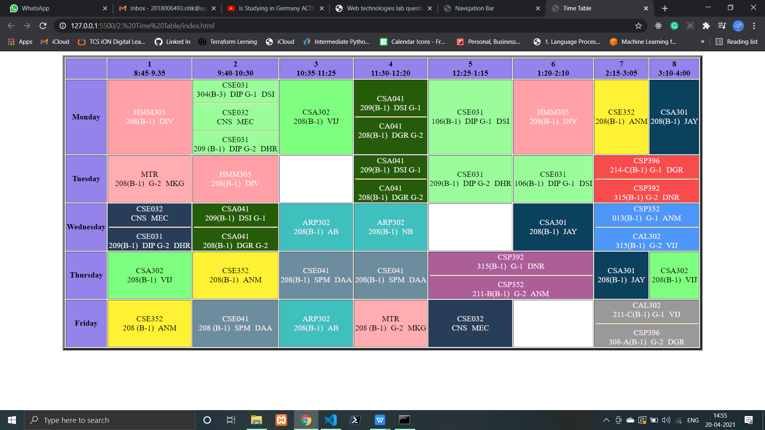

**Date: 3-2-21**

**Experiment 3: Create a web page to show working of ordered, unordered, dictionary and nested list.**

**Solution:**

<!DOCTYPE html>

<html lang="en">

<head>

<meta charset="UTF-8">

<meta http-equiv="X-UA-Compatible" content="IE=edge">

<meta name="viewport" content="width=device-width, initial-scale=1.0">

<title>Lists</title>

<link rel="stylesheet" href="style.css"></head>

<body>

<div class="container">

<div class="ordered">

<div class="search">

<select onchange="csk()" name="selCSK" id="selCSK">

<option value="1">Number</option>

<option value="A">Capital Alphabate</option>

<option value="a">Small Alphabate</option>

<option value="I">Capital Roman Number</option>

<option value="i">Small Roman Number</option></select></div>

<div class="csk">

<h2>Chennai Super Kings</h2>

<img src="https://static.india.com/wp-content/uploads/2020/08/MS-Dhoni-with-CSK-Team-Members-@ipl-File-Image.jpg?impolicy=Medium_Resize&w=1200&h=800" alt="CSK" width="300" style="border-radius: 40px;">

<ol id="csk">

<li>SHANE WATSON</li>

<li>FAF DU PLESIS</li>

<li>SURESH RAINA</li>

<li>AMBATI RAYDU</li>

<li>MS DHONI</li>

<li>RAVINDRA JADEJA</li>

<li>SAM CURRAN</li>

<li>DEEPAK CHAHAR</li>

<li>KARN SHARMA</li>

<li>SHARDUL THAKUR</li>

<li>IMRAN TAHIR</li>

<li>RUTURAJ GAIKWAD</li>

<li>MITCHELL SANTNER</li>

<li>NARAYAN JAGDEESAN</li>

<li>ROBIN UTHAPPA </li>

<li>JOSH HAZLEWOOD </li>

<li>KM ASIF </li>

<li>LUNGI NGIDI </li>

<li>SAI KISHORE </li></ol></div></div>

<div class="unordered">

<div class="search">

<select onchange="mi()" name="selMI" id="selMI">

<option value="disc">Disc</option>

<option value="square"> Square</option>

<option value="circle">Circle</option></select></div>

<div class="mi">

<h2>Mumbai Indians</h2>

<img src="https://i2.wp.com/technosports.co.in/wp-content/uploads/2020/09/EhudYkxVgAIZIRH.jpg?fit=1920%2C1080&ssl=1" alt="MI" width="350" style="border-radius: 40px;">

<ul id="mi">

<li>ROHIT SHARMA</li>

<li>QUINTON DE KOCK</li>

<li>ISHAN KISHAN</li>

<li>SURYAKUMAR YADAV</li>

<li>SAURABH TIWARI</li>

<li>HARDIK PANDYA</li>

<li>KIERON POLLARD</li>

<li>KRUNAL PANDYA</li>

<li>RAHUL CHAHAR</li>

<li>JASPRIT BUMRAH</li>

<li>TRENT BOULT</li>

<li>ANMOLPREET SINGH</li>

<li>CHRIS LYNN</li>

<li>ANUKUL ROY</li>

<li>ADITYA TARE</li>

<li>JAYANT YADAV</li>

<li>MOHSIN KHAN</li>

<li>DHAWAL KULKARNI</li></ul></div></div>

<div class="dictionary">

<h3>IPL Winners</h3>

<img src="https://cdn.dnaindia.com/sites/default/files/styles/full/public/2019/03/22/804660-ipl-2019.jpg" alt="CSK" width="300" style="border-radius: 40px;">

<dl>

<dt>2008</dt>

<dd>Rajasthan Royals</dd>

<dt>2009</dt>

<dd>Deccan Chargers</dd>

<dt>2010</dt>

<dd>Chennai Super Kings</dd>

<dt>2011</dt>

<dd>Chennai Super Kings</dd>

<dt>2012</dt>

<dd>Kolkata Knight Riders</dd>

<dt>2013</dt>

<dd>Mumbai Indians</dd>

<dt>2014</dt>

<dd>Kolkata Knight Riders</dd>

<dt>2015</dt>

<dd>Mumbai Indians</dd>

<dt>2016</dt>

<dd>Sunrisers Hyderabad</dd>

<dt>2017</dt>

<dd>Mumbai Indians</dd>

<dt>2018</dt>

<dd>Chennai Super Kings</dd>

<dt>2019</dt>

<dd>Mumbai Indians</dd>

<dt>2020</dt>

<dd>Mumbai Indians</dd></dl></div>

<div class="nested">

<h3>Openers of Team</h3>

<img src="https://www.insidesport.co/wp-content/uploads/2019/09/IPL-1.jpg" alt="CSK" width="300" style="border-radius: 40px;">

<ul>

<li>CSK

<ol style="list-style-type: armenian;">

<li>RUTURAJ GAIKWAD</li>

<li>FAF DU PLESIS</li></ol></li>

<li>MI

<ol style="list-style-type: cjk-ideographic;">

<li>ROHIT SHARMA</li>

<li>QUINTON DE KOCK</li></ol></li>

<li>SRH

<ol style="list-style-type: georgian;">

<li>DAVID WARNER</li>

<li>JOHNY BAIRSTOW</li></ol></li>

<li>DC

<ol style="list-style-type: hiragana;">

<li>PRITHVI SHAW</li>

<li>SHIKHAR DHAWAN</li></ol></li>

<li>RR

<ol style="list-style-type: katakana;">

<li>YASHASVI JAISWAL</li>

<li>JOS BUTLER</li></ol></li>

<li>KKR

<ol style="list-style-type: hebrew;">

<li>SHUBHMAN GILL</li>

<li>RAHUL TRIPATHI</li></ol></li>

<li>RCB

<ul type="square">

<li>DEVDUTT PADIKKAL</li>

<li>VIRAT KOHLI</li></ul></li>

<li>PK

<ul>

<li>KL RAHUL</li>

<li>MAYANK AGGARWAL</li></ul></li></ul></div></div>

</body>

<script>

function csk() {

let selCSK = document.getElementById('selCSK');

let csk = document.getElementById('csk');

csk.setAttribute('type',selCSK.value ) }

function mi() {

let selMI = document.getElementById('selMI');

let mi = document.getElementById('mi');

mi.setAttribute('type',selMI.value ) }

</script>

</html>

**Style.CSS**

.container{

display: flex;

flex-wrap: wrap;

justify-content: center;

background: url(https://resources.platform.iplt20.com/photo-resources/2020/02/15/920c309c-a894-4f9a-a702-b9ac34725e38/DMIPL11809.JPG?width=2000&height=1333);}

.ordered{

flex: 0 0 35%;

background-color: yellow;

margin: 20px;

padding: 25px;}

.csk, .mi{

margin: 0 10px;}

.search{

margin:  20px 0 10px;}

.ordered select{

background-color: yellow;

width: 200px;

border-radius: 10px;

font-size: 15px;

padding: 5px;

outline: none;}

.unordered{

color: whitesmoke;

flex: 0 0 35%;

background-color: rgb(31, 31, 153);

margin: 20px;

padding: 25px;}

.unordered select{

background-color: rgb(31, 31, 153);

color: whitesmoke;

width: 200px;

border-radius: 10px;

font-size: 15px;

padding: 5px;

outline: none;}

.dictionary{

color: whitesmoke;

flex: 0 0 35%;

background: rgb(2,0,36);

background: linear-gradient(120deg, rgba(2,0,36,1) 0%, rgba(209,14,21,1) 1%, rgba(158,59,59,1) 12%);

margin: 20px;

padding: 25px;}

.nested{

color: whitesmoke;

flex: 0 0 35%;

background-color: rgb(117, 35, 73);

margin: 20px;

padding: 25px;}

**Output:**

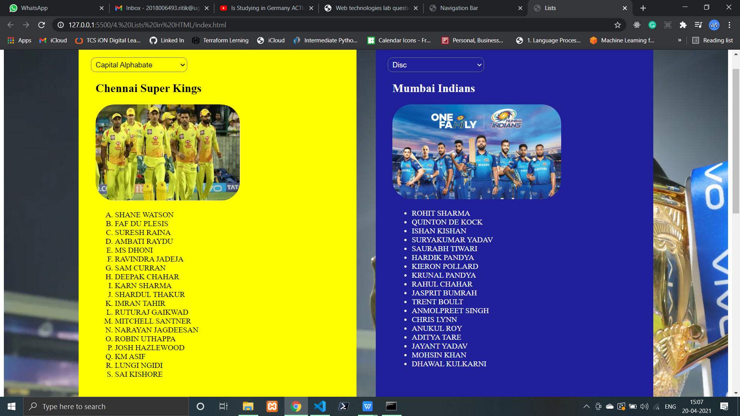

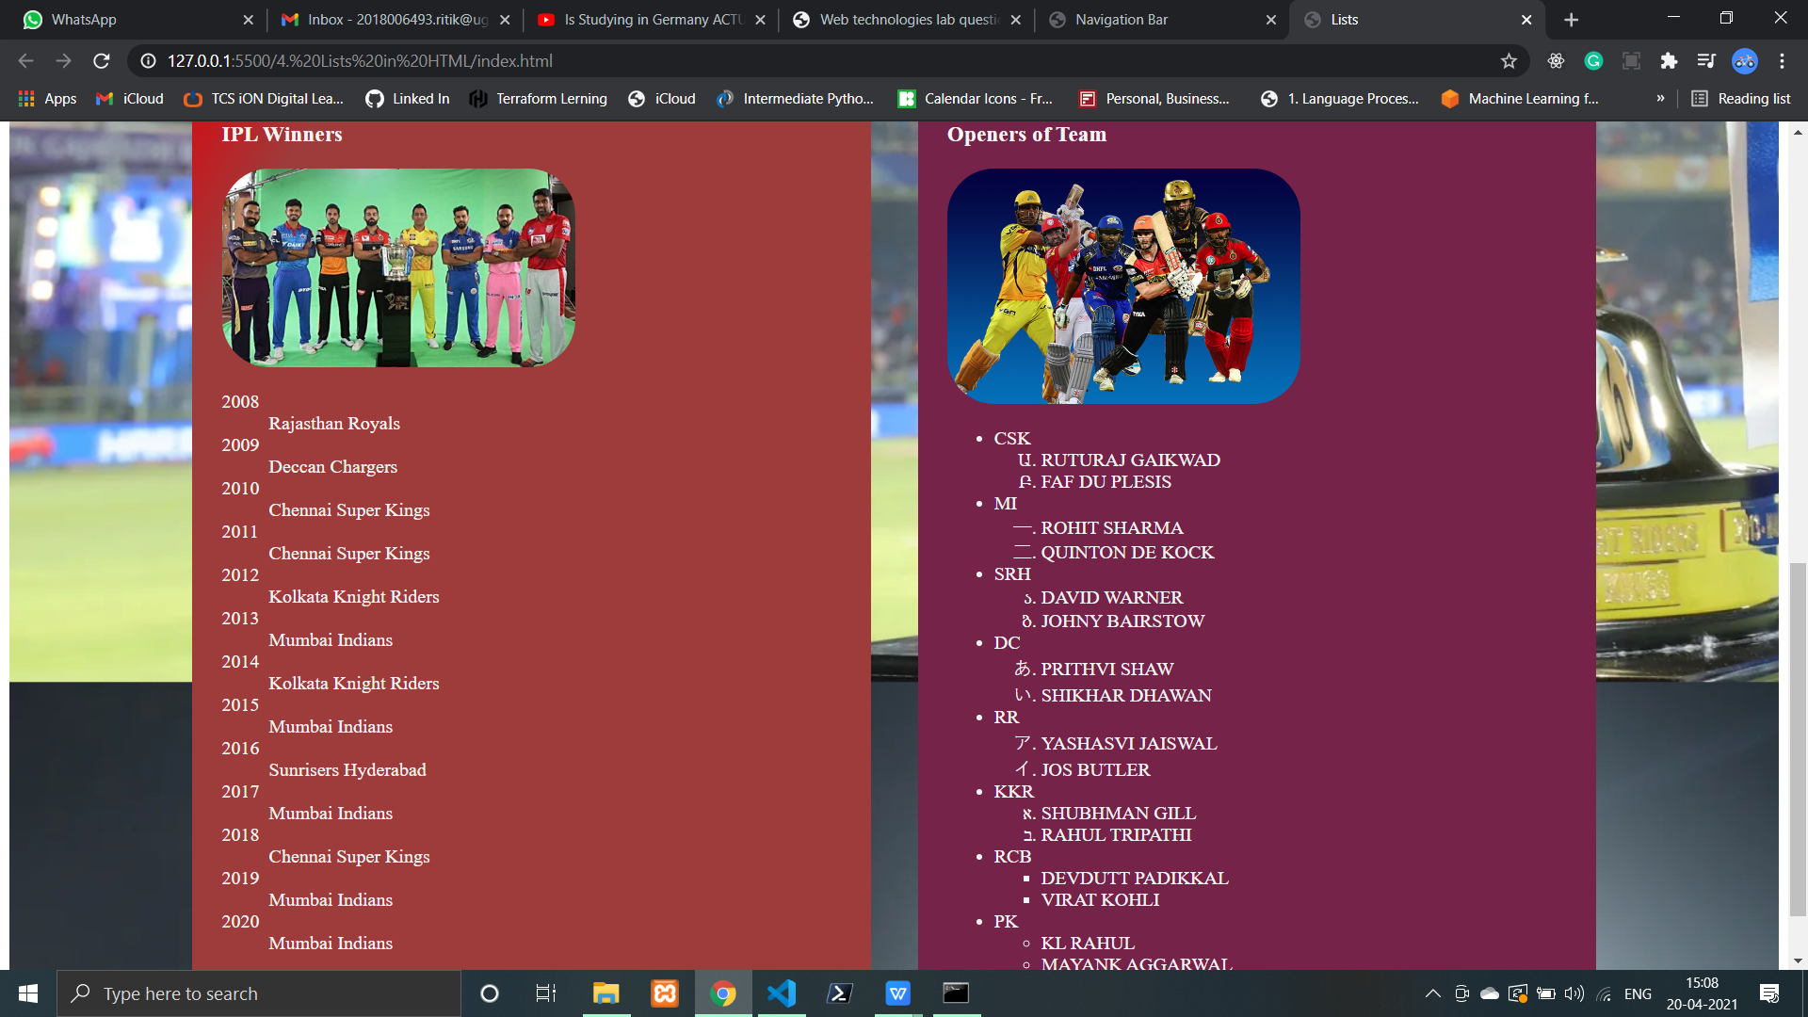

**Date: 10-2-21**

**Experiment 4: Create a registration form with HTML & CSS.**

**Solution:**

<!DOCTYPE html>

<html lang="en">

<head>

<meta charset="UTF-8">

<meta http-equiv="X-UA-Compatible" content="IE=edge">

<meta name="viewport" content="width=device-width, initial-scale=1.0">

<title>Sign-Up Form</title>

<link rel="stylesheet" href="style.css">

</head>

<body>

<div class="container">

<form action="">

<h2>Registration Form</h2>

<p>Enter the following details to create an account.</p>

<hr>

<label for="name">Name: </label>

<input type="text" placeholder="What we call you?" id="name" name="name">

<label for="pass">Password: (8-20)</label>

<input type="password" placeholder="Password length must be 8-20" id="pass" name="pass">

<label for="email">Email Address: </label>

<input type="email" placeholder="example@example.com" id="email">

<label for="phone">Phone Number: </label>

<input type="tel" placeholder="+91" id="phone" name="phone">

<div class="data">

<label for="gender">Gender: </label>

<div class="valid">

<input type="radio" id="male" name="gender">Male

<input type="radio" id="female" name="gender">Female

</div></div>

<label for="dob">Date of Birth: </label>

<input type="date" id="dob" name="dob">

<div class="data">

<label for="lang">Languages: </label><br>

<input type="checkbox" id="eng" name="lang">English

<input type="checkbox" id="hin" name="lang">Hindi

<input type="checkbox" id="tel" name="lang">Telugu

<input type="checkbox" id="tam" name="lang">Tamil

</div>

<label for="address">Address: </label>

<textarea name="address" id="address" rows="5" placeholder="Where do you live?"> </textarea>

<button id="submit" type="submit">Submit</button>

<div id="subMess"></div></form></div></body></html>

**Style.CSS:**

body{

background: url(https://cdn.britannica.com/67/19367-050-885866B4/Valley-Taurus-Mountains-Turkey.jpg);}

.container{

display: flex;

flex-wrap: wrap;

justify-content: center;

padding: 20px;

color: honeydew;}

form{

min-width: 500px;

display: flex;

flex-direction: column;

background-color: rgb(37, 37, 37);

padding: 20px;

opacity: 0.8;

font-family:cursive;}

label{

flex: 0 0 100%;

margin: 10px 0;

font-size: medium;}

input, textarea{

flex: 0 0 100%;

border-radius: 10px;

font-size: 15px;

padding: 5px;

outline: none;}

input:focus, textarea:focus{

border-color: green;

border: 3px solid green;

padding: 7px;}

textarea:hover, input:hover{

padding: 7px;}

.data, .valid{

margin-top: 10px;}

button{

width: 20%;

padding: 5px 0;

background-color: rgb(0, 0, 0);

color: rgb(255, 254, 254);

font-weight: 700;

margin: 10px 0;

cursor: pointer;

outline: none;font-family: 'Lucida Sans', 'Lucida Sans Regular', 'Lucida Grande', 'Lucida Sans Unicode', Geneva, Verdana, sans-serif;}

button:hover{

background: rgb(9, 94, 9);}

p,h2{

margin-top: 2px;

font-family:'Franklin Gothic Medium', 'Arial Narrow', Arial, sans-serif;}

hr{

width: 100%;}

@media(max-width:650px){

form{

min-width: 100%;}}

**Output:**

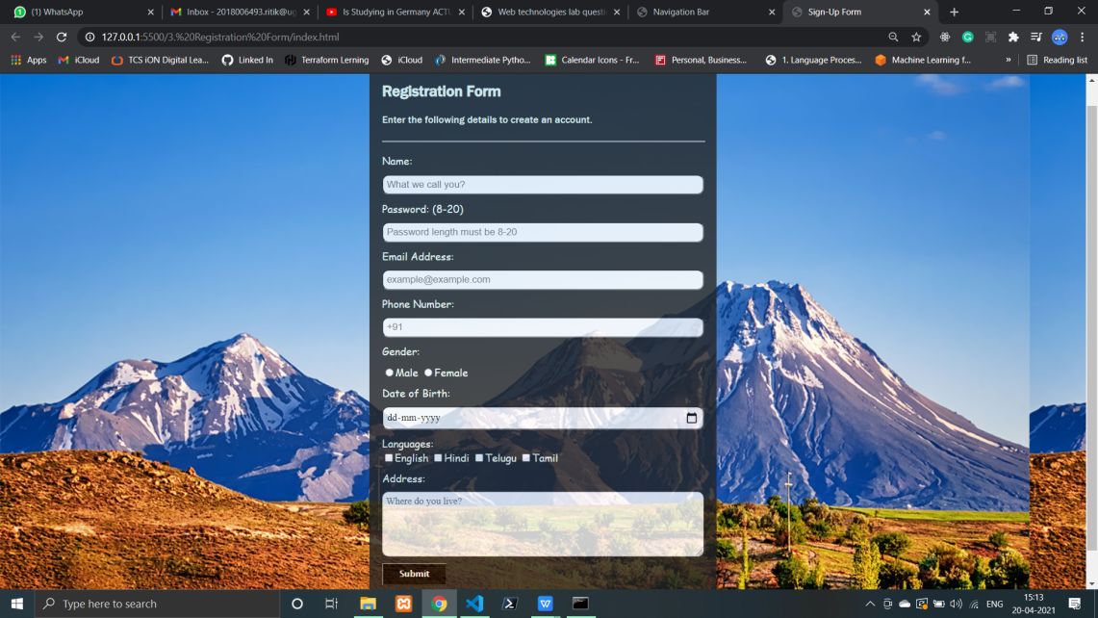

**Date: 17-2-21**

**Experiment 5: Embed audio, video into your HTML page.**

**Solution:**

<!DOCTYPE html>

<html lang="en">

<head>

<meta charset="UTF-8">

<meta http-equiv="X-UA-Compatible" content="IE=edge">

<meta name="viewport" content="width=device-width, initial-scale=1.0">

<title>Audio Video</title>

<link rel="stylesheet" href="style.css">

<link rel="import" href="../7. Navigation Bar/index.html">

</head>

<body>

<div class="container">

<div class="ordered">

<div class="search">

<audio src="csk.mp3" controls></audio></div>

<div class="csk">

<h2>Chennai Super Kings</h2>

<iframe src='https://www.youtube.com/embed/OlGfSKcWhdA?autoplay=1'></iframe>

<ol id="csk">

<li>SHANE WATSON</li>

<li>FAF DU PLESIS</li>

<li>SURESH RAINA</li>

<li>AMBATI RAYDU</li>

<li>MS DHONI</li>

<li>RAVINDRA JADEJA</li>

<li>SAM CURRAN</li>

<li>DEEPAK CHAHAR</li>

<li>KARN SHARMA</li>

<li>SHARDUL THAKUR</li>

<li>IMRAN TAHIR</li>

<li>RUTURAJ GAIKWAD</li>

<li>MITCHELL SANTNER</li>

<li>NARAYAN JAGDEESAN</li>

<li>ROBIN UTHAPPA </li>

<li>JOSH HAZLEWOOD </li>

<li>KM ASIF </li>

<li>LUNGI NGIDI </li>

<li>SAI KISHORE </li>

</ol></div></div>

<div class="unordered">

<div class="search">

<audio src="https://www.soundhelix.com/examples/mp3/SoundHelix-Song-2.mp3" controls></audio></div>

<div class="mi">

<h2>Mumbai Indians</h2>

<video src="bunny.mp4" controls></video>

<ul id="mi">

<li>ROHIT SHARMA</li>

<li>QUINTON DE KOCK</li>

<li>ISHAN KISHAN</li>

<li>SURYAKUMAR YADAV</li>

<li>SAURABH TIWARI</li>

<li>HARDIK PANDYA</li>

<li>KIERON POLLARD</li>

<li>KRUNAL PANDYA</li>

<li>RAHUL CHAHAR</li>

<li>JASPRIT BUMRAH</li>

<li>TRENT BOULT</li>

<li>ANMOLPREET SINGH</li>

<li>CHRIS LYNN</li>

<li>ANUKUL ROY</li>

<li>ADITYA TARE</li>

<li>JAYANT YADAV</li>

<li>MOHSIN KHAN</li>

<li>DHAWAL KULKARNI</li>

</ul></div></div></div></body></html>

**Style.CSS:**

.container{

display: flex;

flex-wrap: wrap;

justify-content: center;

background: rgb(124, 92, 92);}

.ordered{

flex: 0 0 35%;

background-color: yellow;

margin: 20px;

padding: 25px;}

.csk, .mi{

margin: 0 10px;}

.search{

margin:  20px 0 10px;}

.ordered select{

background-color: yellow;

width: 200px;

border-radius: 10px;

font-size: 15px;

padding: 5px;

outline: none;}

.unordered{

color: whitesmoke;

flex: 0 0 35%;

background-color: rgb(31, 31, 153);

margin: 20px;

padding: 25px;}

.unordered select{

background-color: rgb(31, 31, 153);

color: whitesmoke;

width: 200px;

border-radius: 10px;

font-size: 15px;

padding: 5px;

outline: none;}

audio{

outline: none;}

video{

width: 350px;

border-radius: 30px;

outline: none;}

iframe{

width: 350px;

height: 200px;

border-radius: 30px;

outline: none;}

video:hover, iframe:hover{

width: 360px;}

**Output:**

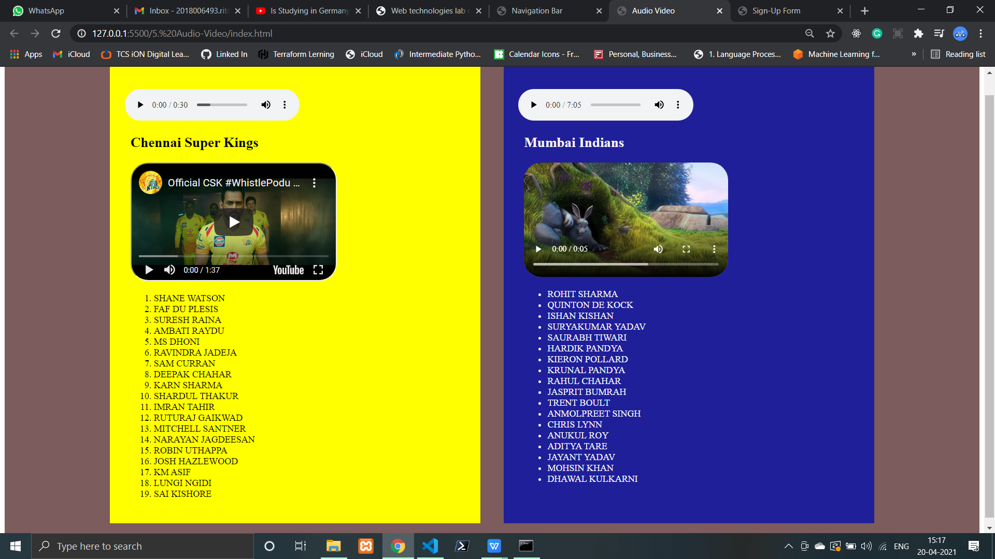

**Date: 24-2-21**

**Experiment 6: Create HTML page to show horizontal, vertical and mixed layout of frames.**

**Solution:**

<!DOCTYPE html>

<html lang="en">

<head>

<meta charset="UTF-8">

<meta http-equiv="X-UA-Compatible" content="IE=edge">

<meta name="viewport" content="width=device-width, initial-scale=1.0">

<title>Frames</title>

<link rel="stylesheet" href="style.css"></head>

<body>

<div class="top">

<iframe src="https://www.youtube.com/embed/OlGfSKcWhdA" frameborder="5" style="background-color: yellow;"></iframe>

<iframe src="https://www.youtube.com/embed/4pJPj_fkQhc" frameborder="5" style="background-color: blue;"></iframe>

<iframe src="https://www.youtube.com/embed/WMWBnOg1t5M" frameborder="5" style="background-color: brown;"></iframe>

<iframe src="https://www.youtube.com/embed/262W91h0xQ0" frameborder="5" style="background-color: green;"></iframe></div>

<div class="middle">

<iframe src="../7. Navigation Bar/index.html" frameborder="5" style="background-color: brown;"></iframe>

<iframe src="../2. Time Table/index.html" frameborder="5" style="background-color: red;"></iframe>

<iframe src="../3. Registration Form/index.html" frameborder="5" style="background-color: rgb(0, 255, 115);"></iframe>

<iframe src="../4. Lists in HTML/index.html" frameborder="5" style="background-color: rgb(0, 247, 255);"></iframe></div>

<div class="bottom">

<iframe src="https://www.youtube.com/embed/6ST7YbX9xwc" frameborder="5" style="background-color: rgb(162, 0, 255);"></iframe>

<div class="foot">

<iframe src="../4. Lists in HTML/index.html" frameborder="5" style="background-color: rgb(255, 0, 200);"></iframe>

<iframe src="../5. Audio-Video/index.html" frameborder="5" style="background-color: rgb(255, 123, 0);"></iframe></div>

<iframe src="https://www.youtube.com/embed/FRBimjvDRdQ" frameborder="5" style="background-color: rgb(255, 0, 34);"></iframe></div></body></html>

**Style.CSS:**

body{

    padding: 0;

    margin: 0;}

iframe{

    padding: 20px;}

.top{

    width: 100%;

    margin: 40px 0;

    display: flex;

    flex-wrap: wrap;

    justify-content: center;}

.top iframe{

    flex: 0 0 22%;

    height: 300px;}

.middle{

    display: flex;

    flex-direction: column;

    align-items: center;

    margin: 20px 0;}

.middle iframe{

    height: 300px;

    width: 90vw;

    margin: 10px 0;}

.bottom{

    display: flex;

    flex-wrap: wrap;

    width: 100%;

    justify-content: center;

    margin: 20px 0;}

.bottom iframe{

    flex: 0 0 31%;}

.bottom .foot{

    flex: 0 0 31%;

    display: flex;

    flex-direction: column;

    margin: 0 5px;}

.bottom .foot iframe:first-child{

    margin-bottom: 10px;}

**Output:**

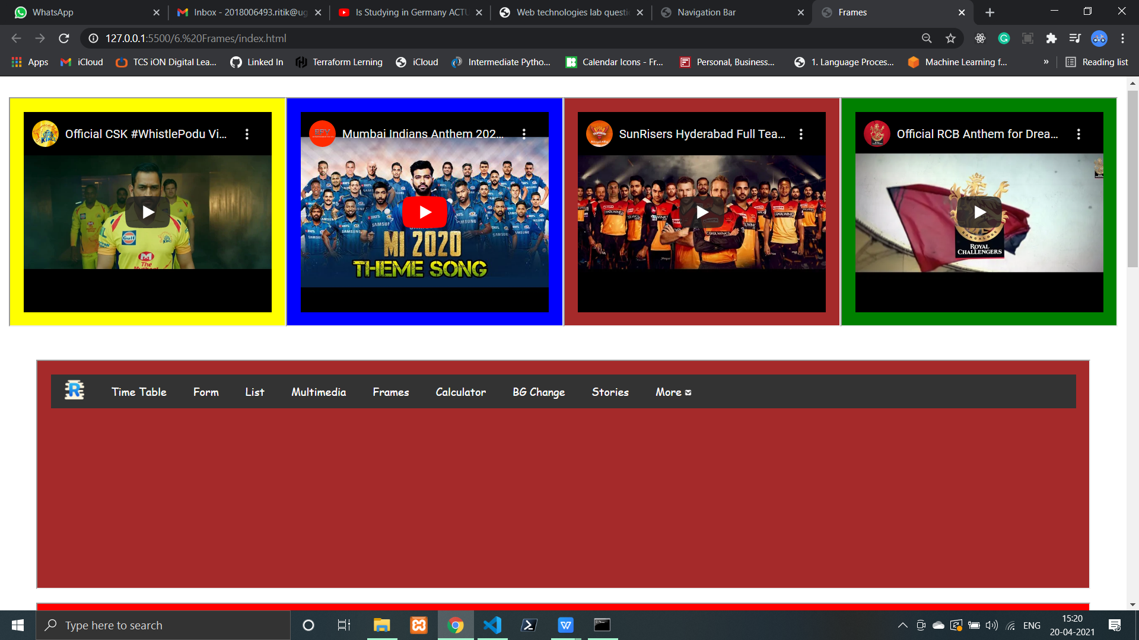

**Date: 10-3-21**

**Experiment 7: Create a navigation bar with CSS.**

**Solution:**

<!DOCTYPE html>

<html lang="en">

<head>

<meta charset="UTF-8">

<meta http-equiv="X-UA-Compatible" content="IE=edge">

<meta name="viewport" content="width=device-width, initial-scale=1.0">

<title>Navigation Bar</title>

<link rel="stylesheet" href="style.css">

<link rel="import" href="../4. Lists in HTML/index.html"></head>

<body>

<nav class="navbar">

<div class="nav-link">

<img class="icon" src="https://img.icons8.com/cute-clipart/30/000000/r--v1.png" />

<a href="../2. Time Table/index.html" target="_blank">Time Table</a>

<a href="../3. Registration Form/index.html" target="_blank">Form</a>

<a href="../4. Lists in HTML/index.html" target="_blank">List</a>

<a href="../5. Audio-Video/index.html" target="_blank">Multimedia</a>

<a href="../6. Frames/index.html" target="_blank">Frames</a>

<a href="../9. Calculator/index.html" target="_blank">Calculator</a>

<a href="../9. Calculator/bgChange.html" target="_blank">BG Change</a>

<a href="../jQuery/stories.html" target="_blank">Stories</a>

<div class="dropdown">

<button class="dropbtn">More

<img src="https://img.icons8.com/metro/10/000000/down-squared.png"

style="background: white; border-radius: 5px;" /></button>

<div class="dropdown-content">

<a href="//terminator1501.herokuapp.com" target="_blank">Portfolio</a>

<a href="mailto: mishraritik86@gmail.com">Mail Me</a>

<a href="tel: +918076694256">Call Me</a></div></div></div></nav>

</body></html>

**Style.CSS:**

body {

    font-family:cursive;

    padding: 0;

    margin: 0;

    user-select: none;}

.navbar {

    overflow: hidden;

    background-color: #333333;}

.icon{

    float: left;

    padding: 8px 20px;}

.navbar a{

    float: left;

    font-size: 16px;

    color: white;

    text-align: center;

    padding: 14px 20px;

    text-decoration: none;}

.dropdown {

    float: left;

    overflow: hidden;}

.dropdown .dropbtn {

    font-size: 16px;

    border: none;

    outline: none;

    color: white;

    padding: 14px 20px;

    background-color: inherit;

    font-family: inherit;

    margin: 0;}

.navbar a:hover, .dropdown:hover .dropbtn {

    background-color: rgb(0, 102, 255);}

.dropdown-content {

    display: none;

    position: absolute;

    background-color: #f9f9f9;

    min-width: 160px;

    box-shadow: 0px 8px 16px 0px rgba(0,0,0,0.2);

    z-index: 1;}

.dropdown-content a {

    float: none;

    color: black;

    padding: 12px 20px;

    text-decoration: none;

    display: block;

    text-align: left;}

.dropdown-content a:hover {

    background-color: #ddd;}

.dropdown:hover .dropdown-content {

    display: block;}

.word{

    margin: 25px;

    width: 150px;

    height: 150px;

    border: 3px solid black;

    word-break: break-all;}

.word-keep{

    margin: 25px;

    width: 150px;

    height: 150px;

    border: 3px solid black;

    word-break: keep-all;}

.word-keep:hover{

    margin: 100px 0;

    transform: translate(100px, 0px, 20px 5px);}

#first {

    border: 10px dotted brown;

    padding: 15px;

    background: lightskyblue;

    background-clip: border-box;

    margin-top: 5px;}

#second {

    border: 10px dotted brown;

    padding: 15px;

    background: lightskyblue;

    background-clip: padding-box;

    margin-top: 5px;}

#three {

    border: 10px dotted brown;

    padding: 15px;

    background: lightskyblue;

    background-clip: content-box;

    margin-top: 5px;}

**Output:**

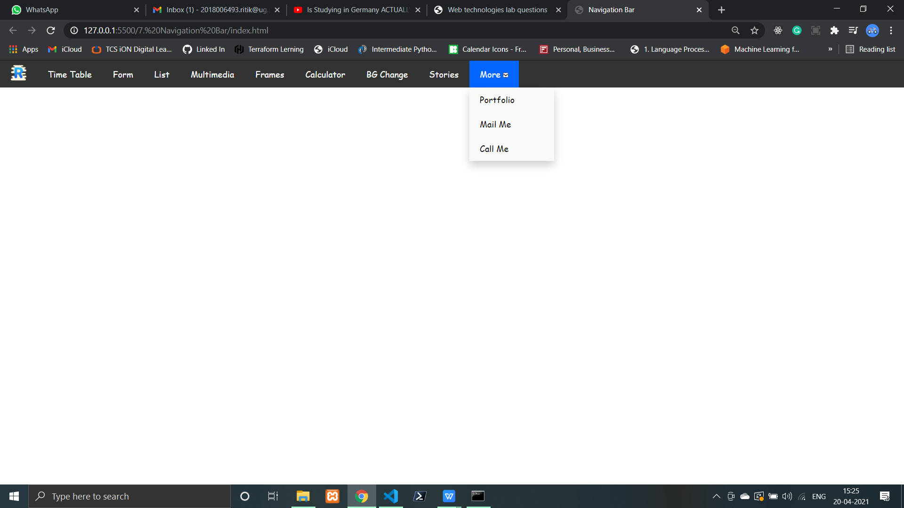

**Date: 17-3-21**

**Experiment 8: Write validation function and on submit property of button on form.**

**Solution:**

<!DOCTYPE html>

<html lang="en">

<head>

<meta charset="UTF-8">

<meta http-equiv="X-UA-Compatible" content="IE=edge">

<meta name="viewport" content="width=device-width, initial-scale=1.0">

<title>Sign-Up Form</title>

<link rel="stylesheet" href="style.css"></head>

<body>

<div class="container">

<form action="">

<h2>Registration Form</h2>

<p>Enter the following details to create an account.</p>

<hr>

<label for="name">Name: </label>

<input type="text" placeholder="What we call you?" id="name" name="name">

<label for="pass">Password: (8-20)</label>

<input type="password" placeholder="Password length must be 8-20" id="pass" name="pass">

<label for="email">Email Address: </label>

<input type="email" placeholder="exam@example.com" id="email" name="email">

<label for="phone">Phone Number: </label>

<input type="tel" placeholder="+91" id="phone" name="phone">

<div class="data">

<label for="gender">Gender: </label>

<div class="valid">

<input type="radio" id="male" name="gender">Male

<input type="radio" id="female" name="gender">Female</div></div>

<label for="dob">Date of Birth: </label>

<input type="date" id="dob" name="dob">

<div class="data">

<label for="lang">Languages: </label><br>

<input type="checkbox" id="eng" name="lang">English

<input type="checkbox" id="hin" name="lang">Hindi

<input type="checkbox" id="tel" name="lang">Telugu

<input type="checkbox" id="tam" name="lang">Tamil</div>

<label for="address">Address: </label>

<textarea name="address" id="address" rows="5" placeholder="Where do you live?"> </textarea>

<button id="submit" type="submit">Submit</button>

<div id="subMess"></div></form></div></body>

<script src="index.js"></script>

</html>

**Index.js:**

let name = document.getElementById('name');

let email = document.getElementById('email');

let phone = document.getElementById('phone');

let password = document.getElementById('pass');

let validName = false;

let validEmail = false;

let validPhone = false;

let validPassword = false;

var message = ""

name.addEventListener('input', function () {

    let reg = /^[a-zA-Z]([ a-zA-Z]){2,20}$/;

    let str = name.value;

    if (reg.test(str)) {

        name.style.borderColor = 'green';

        name.style.borderWidth = '3px';

        validName = true;

        message = ""

    } else {

        name.style.borderColor = 'red';

        name.style.borderWidth = '3px';

        validName = false;

        message = "Name should contain alphabates only and must be in between 2-20";

    }})

email.addEventListener('input', function () {

    let reg = /^([_\-\.a-zA-Z0-9]+)@([a-z]+)\.([a-z.]){2,20}$/;

    let str = email.value;

    if (reg.test(str)) {

        email.style.borderColor = 'green';

        email.style.borderWidth = '3px';

        validEmail = true;

        message =""

    } else {

        email.style.borderColor = 'red';

        email.style.borderWidth = '3px';

        validEmail = false;

        message = "Email format is not valid. Email should be in proper format";

    }})

phone.addEventListener('input', function () {

    let reg = /^([0-9]){10}$/;

    let str = phone.value;

    if (reg.test(str)) {

        phone.style.borderColor = 'green';

        phone.style.borderWidth = '3px';

        validPhone = true;

        message=""

    }else {

        phone.style.borderColor = 'red';

        phone.style.borderWidth = '3px';

        validPhone = false;

        message = "Phone Number should be 10 digits long and contains numbers only";

    }})

password.addEventListener('input', function () {

    let reg = /^([a-zA-Z0-9!@#$%^&*]){8,20}$/;

    let str = password.value;

    if (reg.test(str)) {

        password.style.borderColor = 'green';

        password.style.borderWidth = '3px';

        validPassword = true;

        message=""

    }else {

        password.style.borderColor = 'red';

        password.style.borderWidth = '3px';

        validPassword = false;

        message = "Password length must be 2-20";

    }})

subMess = document.getElementById('subMess');

let btnSubmit = document.getElementById('submit');

btnSubmit.addEventListener('click', function(e){

    e.preventDefault();

    if(validEmail && validName && validPhone){

        subMess.innerHTML = `<h3>Your form is submitted Sucessfully...</h3>`;

    }else{

        subMess.innerHTML = message;

        alert(message+'\nYour form is not submitted...Try Again with valid credentials')

    }})

**Output:**

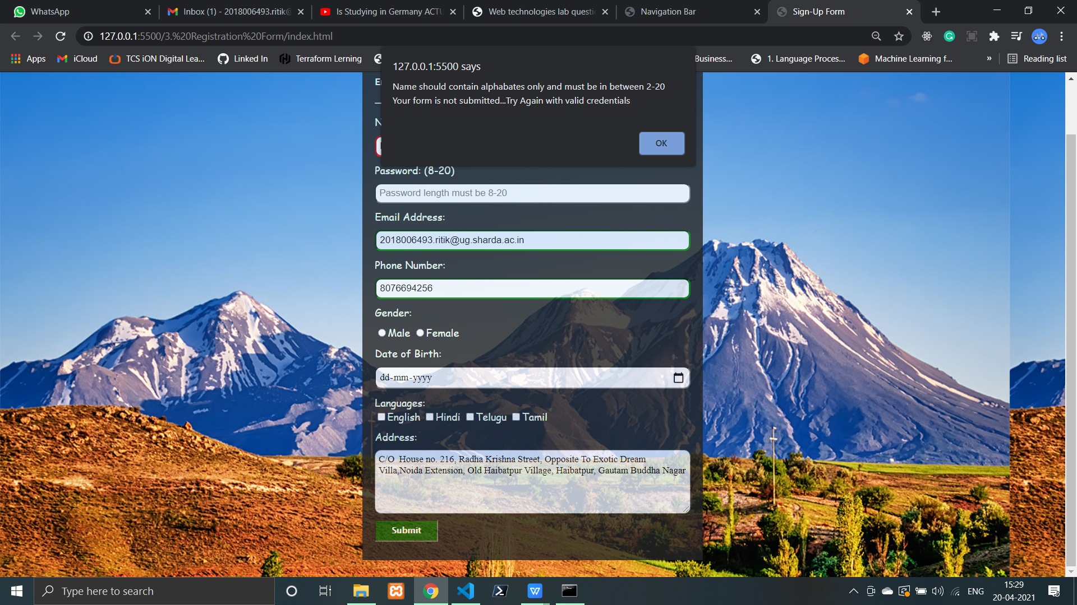

**Date: 24-3-21**

**Experiment 9:**

1. **Write java-script program to change background color.**
2. **Create a calculator using java-script.**
3. **Create java-script program for toggle button.**
4. **Solution:**

<!DOCTYPE html>

<html lang="en">

<head>

<meta charset="UTF-8">

<meta http-equiv="X-UA-Compatible" content="IE=edge">

<meta name="viewport" content="width=device-width, initial-scale=1.0">

<title>Background Change</title>

<style>

a{

font-size: 20px;

margin: 20px;

padding: 20px;

text-decoration: none;

color: black;

font-weight: 800;}

</style></head>

<body>

<a href="#" id="white">White</a>

<a href="#" id="red">Red</a>

<a href="#" id="blue">Blue</a>

<a href="#" id="pink">Pink</a>

</body>

<script>

let white = document.getElementById("white");

let red = document.getElementById("red");

let blue = document.getElementById("blue");

let pink = document.getElementById("pink");

red.addEventListener('click', ()=>{

document.body.style.backgroundColor = "red";

});

blue.addEventListener('click', ()=>{

document.body.style.backgroundColor = "blue";

});

pink.addEventListener('click', ()=>{

document.body.style.backgroundColor = "pink";

});

white.addEventListener('click', ()=>{

document.body.style.backgroundColor = "white";

});

</script>

</html>

**Output:**

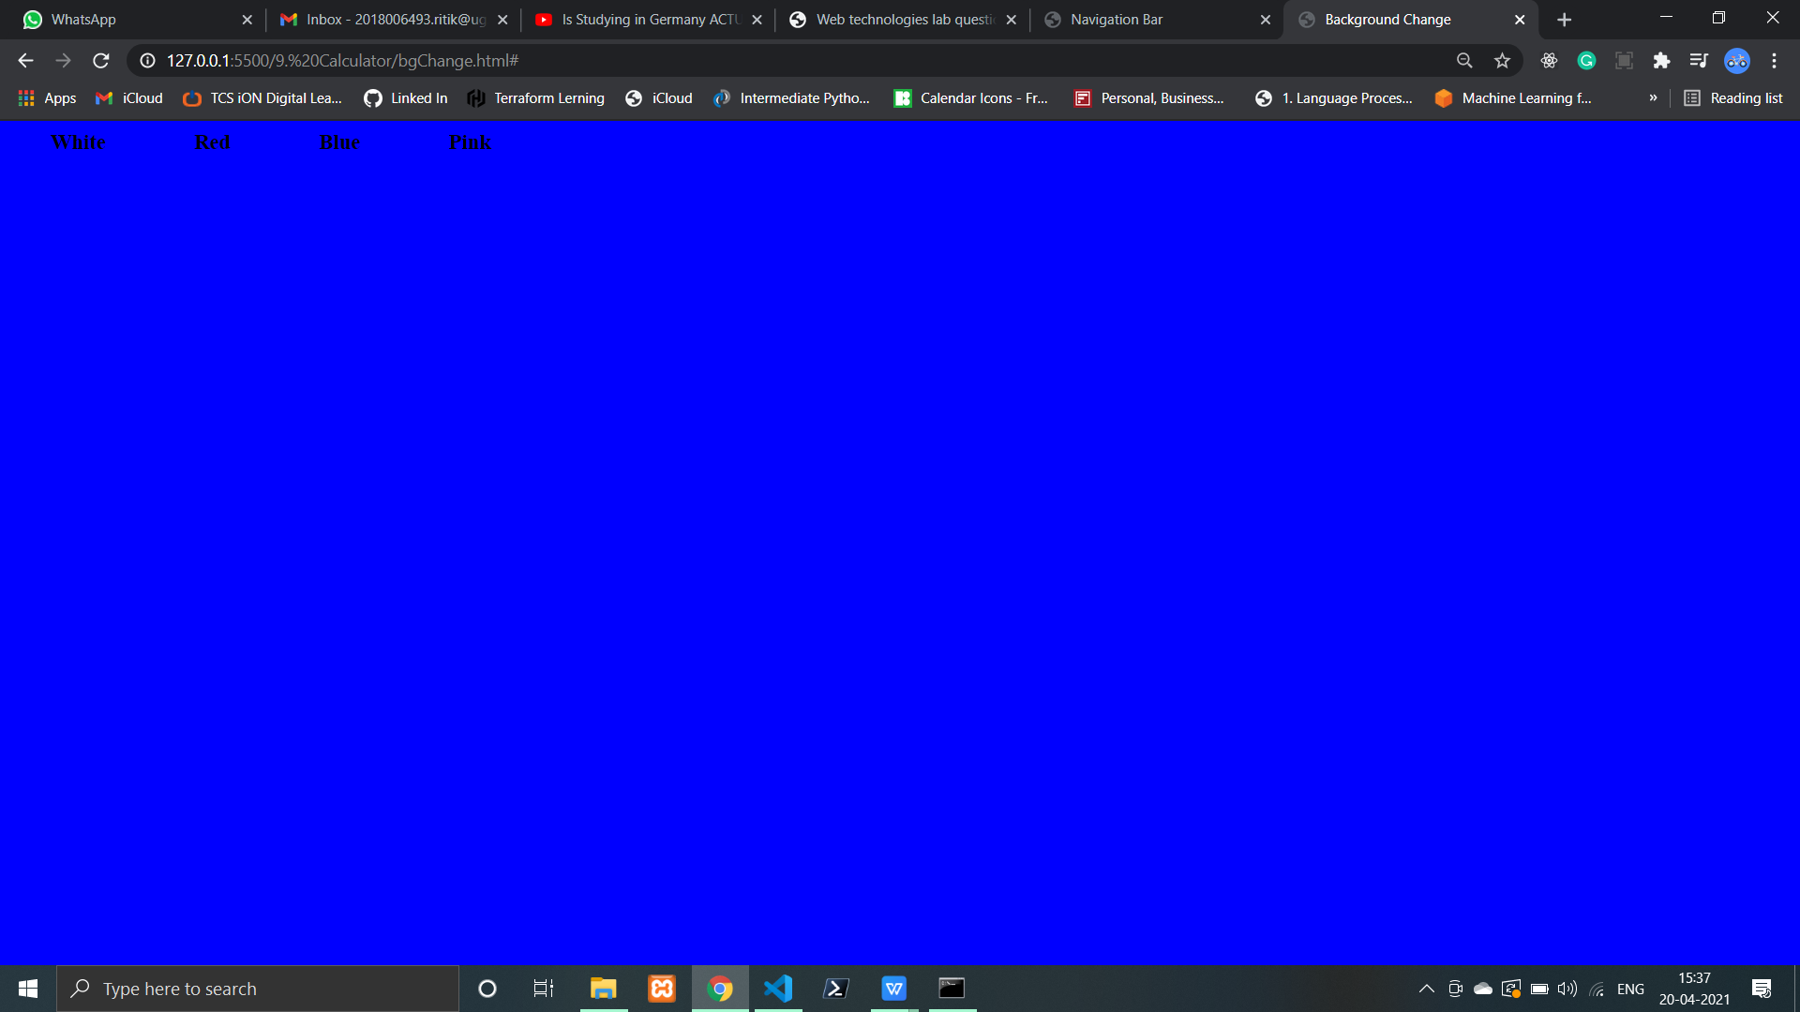

1. **Solution:**

<!DOCTYPE html>

<html lang="en">

<head>

<meta charset="UTF-8">

<meta name="viewport" content="width=device-width, initial-scale=1.0">

<title>Calculator JS</title>

<link rel="stylesheet" href="style.css"></head>

<body>

<div class="container">

<div class="calc">

<h1>Calculator</h1>

<input type="text" name="screen" id="screen" readonly>

<table>

<tr><td>

<button>C</button>

<button>(</button>

<button>)</button>

<button>%</button>

</td></tr>

<tr><td>

<button>9</button>

<button>8</button>

<button>7</button>

<button>/</button>

</td></tr>

<tr><td>

<button>6</button>

<button>5</button>

<button>4</button>

<button>X</button>

</td></tr>

<tr><td>

<button>3</button>

<button>2</button>

<button>1</button>

<button>-</button>

</td></tr>

<tr><td>

<button>0</button>

<button>.</button>

<button>=</button>

<button>+</button>

</td></tr></table></div></div>

<script src="index.js"></script>

</body></html>

**Style.CSS:**

body{

position: relative;

top: 20vh;

display: flex;

justify-content: center;

align-items: center;

background-image: url(https://images.ctfassets.net/hrltx12pl8hq/6TOyJZTDnuutGpSMYcFlfZ/4dfab047c1d94bbefb0f9325c54e08a2/01-nature_668593321.jpg?fit=fill&w=480&h=270);

background-size: cover;}

.container{

text-align: center;

box-sizing: border-box;}

input{

font-size: 20px;

height: 40px;

width: 300px;

border-radius: 1cm;

padding-left: 15px;

outline: none;}

table{

margin: auto;

margin-top: 20px;}

button{

background: linear-gradient(to right, #9e41f5, #0026fa);

color: white;

height: 60px;

width: 60px;

border-radius: 25px;

font-size: 25px;

outline: none;}

.calc{

color: white;

display: inline-block;

background-color: rgb(25, 25, 25);

border-radius: 1cm;

padding: 10px;

padding-bottom: 35px;}

**Index.js**

let screen = document.getElementById('screen');

let button = document.querySelectorAll('button');

let screenValue = '';

for (item of button){

    item.addEventListener('click', (e)=>{

        let buttonText = e.target.innerText;

        if(buttonText == 'X'){

            buttonText = '*'

            screenValue += buttonText;

            screen.value += buttonText;

        }else if(buttonText == 'C'){

            screen.value = '';

            screenValue = '';

        } else if(buttonText == '='){

            try {

                screen.value = eval(screenValue);

            } catch (error) {

                screen.value = 'ERROR!!'

                alert("ERROR !! Please Enter Right Values...")

            }        }

        else{

            screenValue += buttonText;

            screen.value = screenValue;

        }    }) }

**Output:**

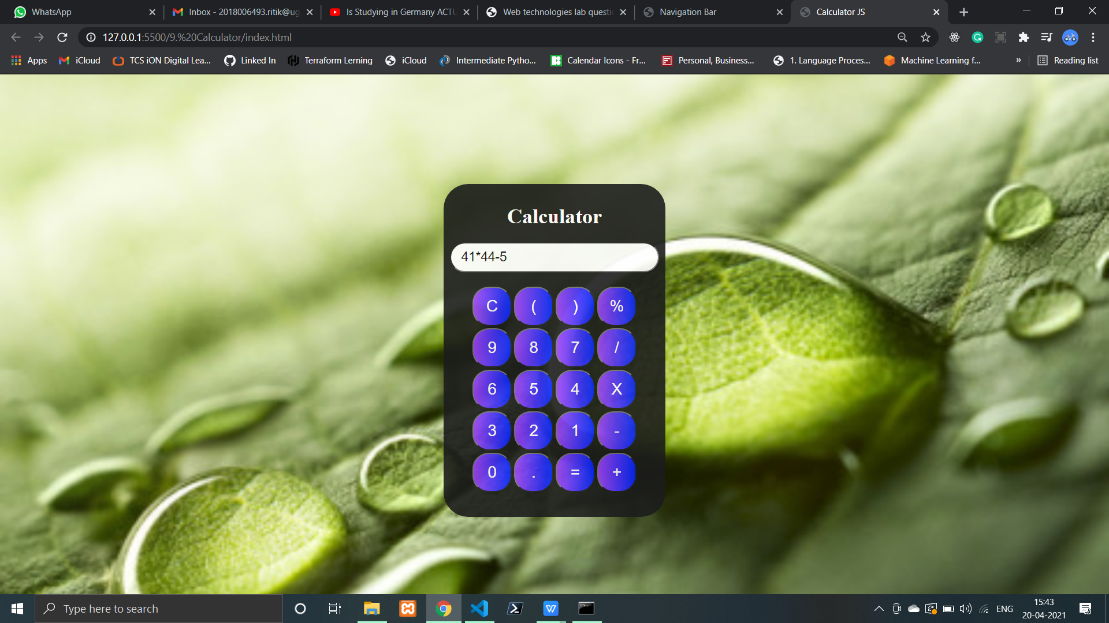

**Date: 31-3-21**

**Experiment 10:**

1. **Create jQuery program to hide an element.**
2. **Create jQuery program to show alert when we hover an element.**
3. **Show the effects of SlideUp, SlideDown and fade.**

**Solution:**

<!doctype html>

<html lang="en">

<head>

<!-- Required meta tags -->

<meta charset="utf-8">

<meta name="viewport" content="width=device-width, initial-scale=1, shrink-to-fit=no">

<link rel="stylesheet" href="https://maxcdn.bootstrapcdn.com/bootstrap/4.0.0/css/bootstrap.min.css"

integrity="sha384-Gn5384xqQ1aoWXA+058RXPxPg6fy4IWvTNh0E263XmFcJlSAwiGgFAW/dAiS6JXm" crossorigin="anonymous">

<title>jQuery</title>

</head>

<style>

body {

background: linear-gradient(90deg, #e3ffe7 0%, #d9e7ff 100%);}

.story1 {

background: rgb(2, 0, 36);

background: radial-gradient(circle, rgba(2, 0, 36, 1) 0%, rgba(73, 205, 150, 1) 0%, rgba(29, 113, 57, 1) 100%);}

.story2 {

background: rgb(2, 0, 36);

background: radial-gradient(circle, rgba(2, 0, 36, 1) 0%, rgba(118, 205, 73, 1) 0%, rgba(0, 212, 255, 1) 100%);}

</style>

<body>

<div class="container my-5">

<div class="row">

<div class="col-md-6">

<h2 class="mx-3 data">Short Stories</h2></div>

<div class="col-md-2"><button class="btn btn-danger" id="val" onclick="fade()">Next Story</button></div>

<div class="col-md-2">

<button class="btn btn-primary" id="show">Slide Down Image</button>

<button class="btn btn-primary" id="hide">Slide Up Image</button></div>

<div class="col-md-2"><button class="btn btn-info" id="message">Hover Me</button></div></div>

<div class="story1 my-3 p-5">

<h4>The lion and the Mouse</h4>

A lion was once sleeping in the jungle when a mouse started running up and down hisbody just for fun. This disturbed the lion’s sleep, and he woke up quite angry. He was about to eat the mouse when the mouse desperately requested the lion to set him free. “I promise you, I will be of great help to you someday if you save me.” The lion laughed at the mouse’s confidence and let him go. One day, a few hunters came into the forest and took the lion with them. They tied him up against a tree. The lion was struggling to get out and started to whimper. Soon, the mouse walked past and noticed the lion in trouble. Quickly, he ran and gnawed on the ropes to set the lion free. Both of them sped off into the jungle.

<div class="moral">

<strong>Moral of the Story: </strong> <u>A small act of kindness can go a long way.</u></div>

<div id="image">

<img class="img-fluid mx-auto my-3"

src="https://cdn2.momjunction.com/wp-content/uploads/2016/02/The-Lion-And-The-Mouse-Story-For-Your-Kid.jpg"

alt="Story1" style="min-width: 90%;"></div></div>

<div class="story2 my-3 p-5">

<h2>The Fox and the Stork</h2>

One day, a selfish fox invited a stork for dinner. Stork was very happy with the invitation – she reached the fox’s home on time and knocked at the door with her long beak. The fox took her to the dinner table and served some soup in shallow bowls for both of them. As the bowl was too shallow for the stork, she couldn’t have soup at all. But, the fox licked up his soup quickly. The stork was angry and upset, but she didn’t show her anger and behaved politely. To teach a lesson to the fox, she then invited him for dinner the next day. She too served soup, but this time the soup was served in two tall narrow vases. The stork devoured the

soup from her vase, but the fox couldn’t drink any of it because of his narrow neck. The fox realised his

mistake and went home famished.

<div class="moral">

<strong>Moral of the Story: </strong> <u>A selfish act backfires sooner or later!</u>

</div>

<div id="image">

<img class="img-fluid mx-auto my-3"

src="https://cdn.cdnparenting.com/articles/2019/12/21100406/The-Fox-and-the-Stork.jpg" alt="Story2"></div></div></section></div>

<script src="https://ajax.googleapis.com/ajax/libs/jquery/3.5.1/jquery.min.js"> </script><script>

$(document).ready(() => {

$('.story2').hide();

$('#show').hide(); })

$('#hide').click(() => {

$('#image').slideUp()

$('#show').toggle();

$('#hide').toggle();

$('.data').fadeOut(); })

$('#show').click(() => {

$('#image').slideDown()

$('#show').toggle();

$('#hide').toggle();

$('.data').fadeIn(); })

$('#message').hover(() => {

alert("Are you Enjoying Our Stories? ");

$('#message').hide(); });

function fade() {

$('.story1, .story2').fadeToggle(); }

</script></body></html>

**Output:**

